New report;

**From:** Jack Fong [mailto:jack.fong@dbschenker.com]   
**Sent:** Thursday, 05 June, 2014 9:58 AM

The report can be in MS Excel format as per below:

Shipment No. | Ship-to Company | Country | Order Type (Trade / Interco) | Pallet ID | SKU | Batch | Quantity | Finalise Date

For retrieval, will be by Shipment No.

Can we also add the date as retrieval parameter?

Target: Jun 2014

Kodigo WMS changes:

Report – Outbound Container Shipment Detail

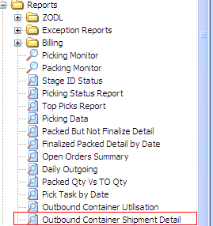

Report retrieval:

* Shipment No : (Optional)
* Finalize date from :
* Finalize date to:

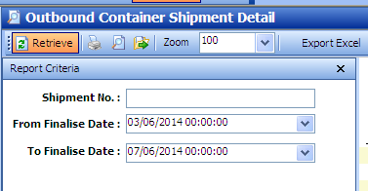

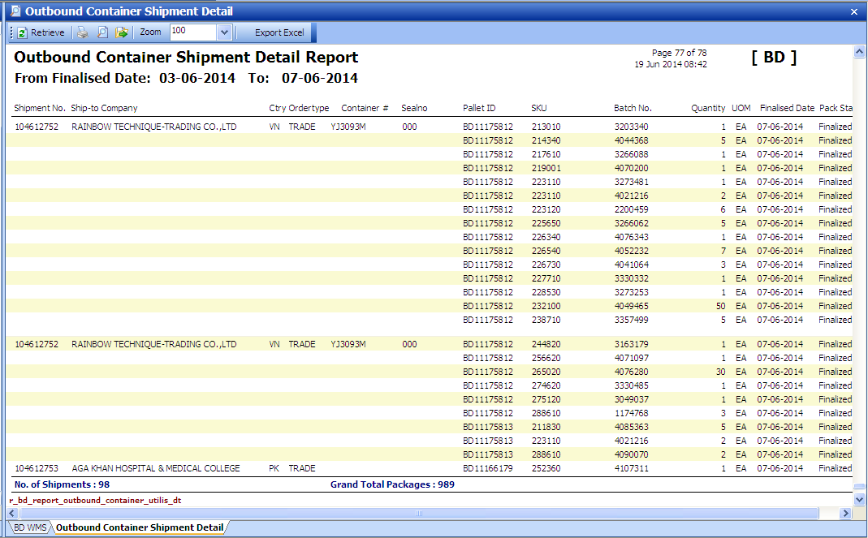

Save as Excel:

